CBCA WA Book Discussion Group Books Read in 2022

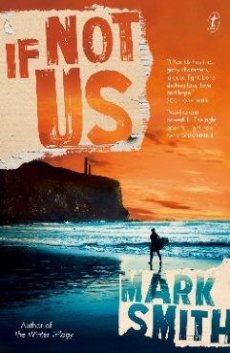 | If Not Us by Mark Smith  Publisher site: https://www.textpublishing.com.au/books/if-not-us
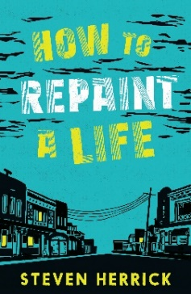 | How to Repaint a Life by Steven Herrick  Honour Book – 2022 CBCA Book of the Year Award: Older Readers  Publisher’s Website: https://www.uqp.com.au/books/how-to-repaint-a-life  CBCA Reading Time Review: https://readingtime.com.au/how-to-repaint-a-life/
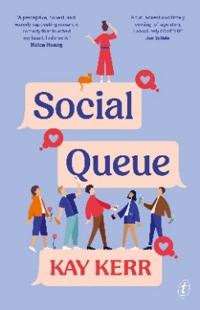 | Social Queue by Kay Kerr  Notable Book – 2022 CBCA Book of the Year Award: Older Readers  Publisher’s Website: https://www.textpublishing.com.au/books/social-queue  CBCA Reading Time Review: https://readingtime.com.au/social-queue/
The 2022 CBCA Short List Discussion
17 people including the CBCA Judge for the Younger Readers category, Claire Kierath. Participated in this event held at Oasis Lotteries House.
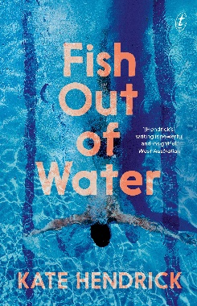 | Fish Out of Water by Kate Henrick  Publisher’s Website: https://www.textpublishing.com.au/books/fish-out-of-water  CBCA Reading Time Review: https://readingtime.com.au/fish-out-of-water/
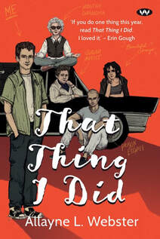 | That Thing I Did by Allayne L. Webster  Publisher’s Website: https://www.wakefieldpress.com.au/product.php?productid=1759  CBCA Reading Time Review:
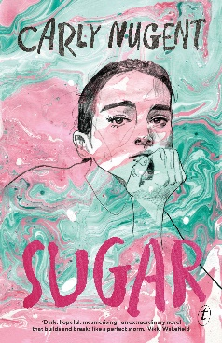 | Sugar by Carly Nugent  Publisher’s Website: https://www.textpublishing.com.au/books/sugar
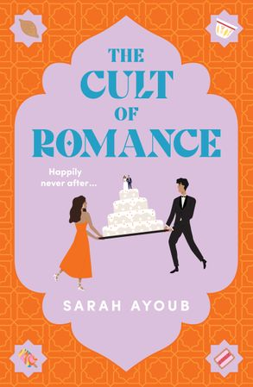 | The Cult of Romance by Sarah Ayoub  Publisher’s Website: https://www.harpercollins.com.au/9781460712689/the-cult-of-romance/  CBCA Reading Time Review: https://readingtime.com.au/the-cult-of-romance/
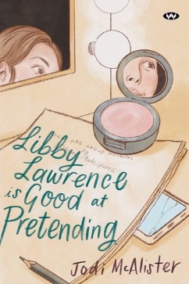 | Libby Lawrence is Good at Pretending by Jodi McAlister  Publisher’s Website: https://www.wakefieldpress.com.au/product.php?productid=1778  Notable Book – 2023 CBCA Book of the Year Award: Older Readers
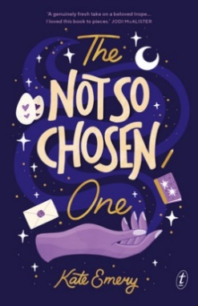 | The Not So Chosen One by Kate Emery  Publisher’s Website: https://www.textpublishing.com.au/books/the-not-so-chosen-one  Notable Book – 2023 CBCA Book of the Year Award: Older Readers
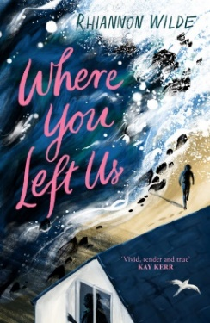 | Where You Left Us by Rhiannon Wilde  Publisher’s Website: https://www.uqp.com.au/books/where-you-left-us  CBCA Reading Time Review: https://readingtime.com.au/where-you-left-us/  Notable Book – 2023 CBCA Book of the Year Award: Older Readers

