CBCA WA Book Discussion Group – Books Read in 2023

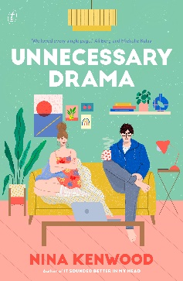 | Unnecessary Drama by Nina Kenwood (Text Publishing)  Notable Book - 2023 CBCA Book of the Year Award: Older Readers  Publisher’s Website: https://www.textpublishing.com.au/books/unnecessary-drama  CBCA Reading Time Review: https://readingtime.com.au/unnecessary-drama/
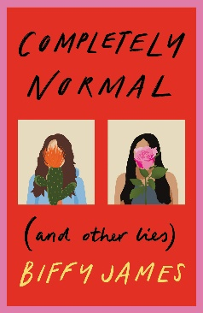 | Completely Normal (and Other Lies) by Biffy James (Hardie Grant Publishing)  Honour Book – 2023 CBCA Book of the Year Award: Older Readers  Publisher’s Website: https://www.hardiegrant.com/au/publishing/bookfinder/book/completely-normal-_and-other-lies_-by-biffy-james/9781760508746  CBCA Reading Time Review: https://readingtime.com.au/completely-normal-and-other-lies/
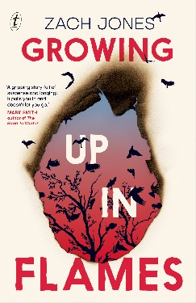 | Growing Up In Flames by Zach Jones (Text Publishing)  Publisher’s Website: https://www.textpublishing.com.au/books/growing-up-in-flames
The 2023 CBCA Book of the Year Shortlist Review
Books were reviewed by CBCA WA members including the CBCA Judge for the Younger Readers category,
Claire Kierath at Iona Presentation College.
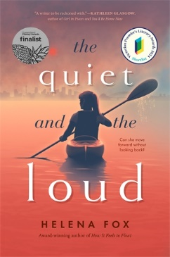 | The Quiet and the Loud by Helena Fox (Pan Macmillan Australia)  Publisher’s Website: https://www.panmacmillan.com.au/9781760983024/  CBCA Reading Time Review: https://readingtime.com.au/the-quiet-and-the-loud/
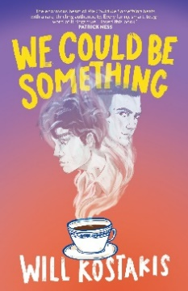 | We Could Be Something by Will Kostakis (A & U Children’s)  Publisher’s Website: https://www.allenandunwin.com/browse/book/Will-Kostakis-We-Could-Be-Something-9781761180170/  CBCA Reading Time Review: https://readingtime.com.au/we-could-be-something/
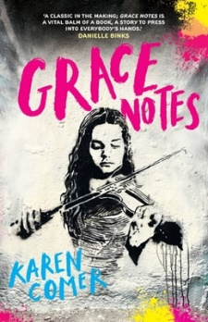 | Grace Notes by Karen Comer (Hachette Australia)  Publisher’s Website: https://www.hachette.com.au/karen-comer/grace-notes  CBCA Reading Time Review: https://readingtime.com.au/grace-notes/
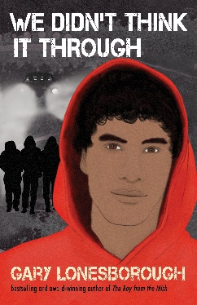 | We Didn’t Think It Through by Gary Lonesborough (Allen & Unwin)  Publisher’s Website: https://www.allenandunwin.com/browse/book/Gary-Lonesborough-We-Didn't-Think-It-Through-9781760526931  CBCA Reading Time Review: https://readingtime.com.au/we-didnt-think-it-through/
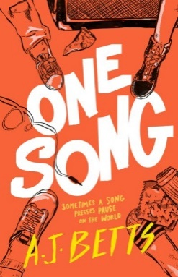 | One Song by AJ Betts (Pan Macmillan Australia)  Publisher’s Website: https://www.panmacmillan.com.au/9781761264900/
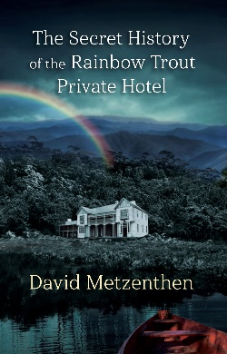 | The Secret History of the Rainbow Trout Private Hotel by David Metzenthen  Publisher’s Website: https://fordstreetpublishing.com/book/the-secret-history-of-the-rainbow-trout-private-hotel/  CBCA Reading Time Review: https://readingtime.com.au/the-secret-history-of-the-rainbow-trout-private-hotel/
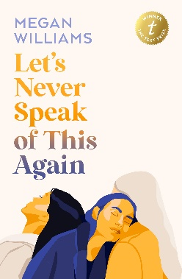 | Let’s Never Speak of This Again by Megan Williams (Text Publishing)  Publisher’s Website: https://www.textpublishing.com.au/books/let-s-never-speak-of-this-again  CBCA Reading Time Review: https://readingtime.com.au/lets-never-speak-of-this-again/

